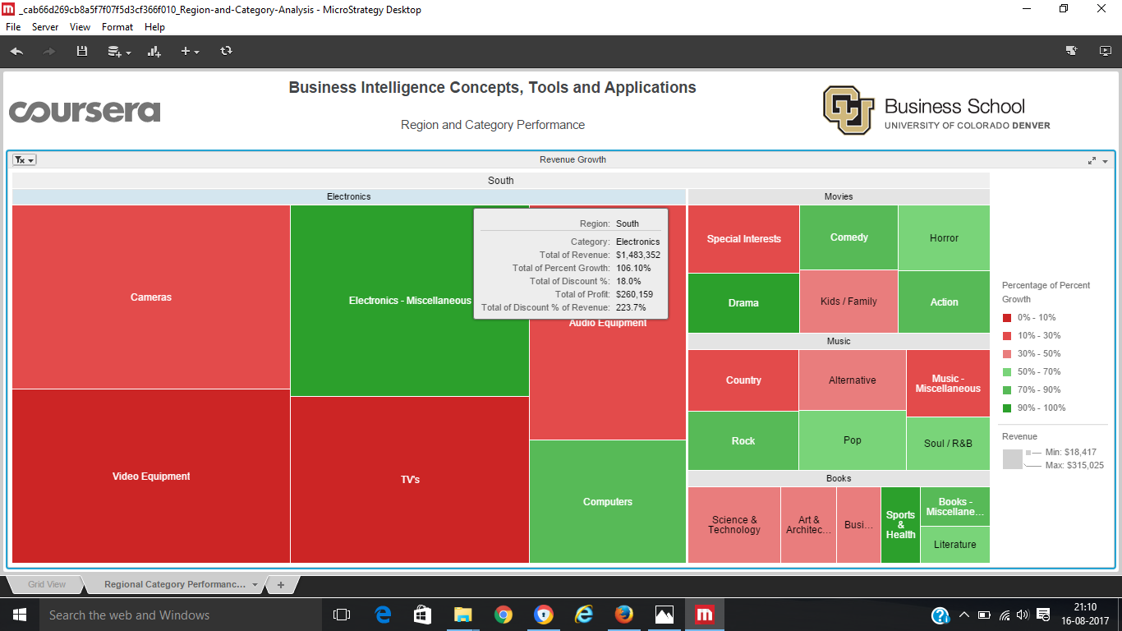

Ans: Biggest selling category of South region is “Electronics”. It has the biggest square region over all categories in south region.